

FINAL YEAR PROJECT

Ascend Pro

BY
Adil Abdullah 2180103
Humdan Khattak 2080109
Daeyan Siddiqui 2180121

SUPERVISOR
Mr. Aqeel Soomro

COMPUTER SCIENCE DEPARTMENT
SHAHEED ZULFIKAR ALI BHUTTO INSTITUTE OF
SCIENCE & TECHNOLOGY

2025

Table of Contents
Abstract i
Acknowledgements ii
Acronyms iii
List of Figures iv
List of Tables v
Chapter 1 Introduction 1
1.1 Movitations 1
1.2 Objectives and Scope 2
1.3 Methodology 3
1.4 Organizations……………………… …………………………………………………….5

Chapter 2 Literature Review …………………………………….............................................8

2.1 Summary 8
2.2 The Need for Such Apps 8
2.3 Considerations for Design and Development…………………………………..9

2.4 Features of Ascend Pro..……………………………………….………………10

2.5 Application Graphical User Interface………………………...………………..14

2.6 Databases……………………………………………………...……………….17

Chapter 3 Findings………………………………………............................................ 21
3.1 Cost 21
3.2 Schedule 21
3.3 Side Effects…………………………………………………………………….22

3.4 Residual Risks…………………………………………………………………23

Chapter 4 Conclusions and Future Work…………………………………………….... 24

4.1 Conclusions 24
4.2 Recommendatin in Future Work……………………………………………….24

References …………………………………………………………………………………………….27

Appendix ...……….…………………………………………………………………………………...28

Abstract
AscendPro is an AI powered platform developed as a Final Year Project to revolutionize the way employees manage their meetings, professional development, and workplace communication. The platform addresses key organizational challenges by combining real time meeting transcription and summarization, and AI generated career roadmaps, all within a responsive and user friendly web interface.
Built using modern web technologies like React.js, Next.js, and Python, and integrated with APIs such as OpenAI Whisper and Google Gemini, AscendPro provides a centralized solution for both individual productivity and organizational efficiency. Its core modules enable users to automate administrative tasks, visualize career paths, and practice interpersonal communication in a safe simulated environment.
The platform targets mid level professionals, team leaders, and HR departments seeking smarter solutions for employee enablement. AscendPro stands out for its modular design, data security measures, and its potential for future expansion into mobile apps and enterprise integrations. This report documents the research, design, development, evaluation, and deployment of the AscendPro system.

Acknowledgements
First and foremost, we express our heartfelt gratitude to our parents, whose unwavering love, patience, and encouragement have been the foundation of our academic journey. Their sacrifices, prayers, and support have given us the strength and motivation to persevere through every challenge we faced during this Final Year Project. We dedicate this work to them with immense respect and appreciation.
We would like to extend our sincere thanks to our project supervisor, Mr. Aqeel Soomro, for his continuous guidance, insightful feedback, and technical mentorship throughout the development of AscendPro. His support played a crucial role in helping us refine our ideas and bring this project to completion.
We also thank the faculty members of the Computer Science Department at SZABIST Hyderabad for providing us with a strong academic foundation and for always being available to help and advise us during our degree program.
Our appreciation also goes out to our peers and classmates who contributed valuable suggestions during testing and evaluations. Their feedback helped us improve both functionality and user experience.
Finally, we are grateful to everyone who supported us, directly or indirectly, during this journey. Your belief in our abilities made a significant difference.
Adil Abdullah (2180103)
Humdan Khattak (2080109)
Daeyan Siddiqui (2180121)
SZABIST, Hyderabad
May 2025

Acronyms
Acronym | Full Form
AI | Artificial Intelligence
API | Application Programming Interface
NLP | Natural Language Processing
UI | User Interface
UX | User Experience
FYP | Final Year Project
JWT | JSON Web Token
GDPR | General Data Protection Regulation
CCPA | California Consumer Privacy Act
REST API | Representational State Transfer Application Programming Interface
OAuth | Open Authorization (2.0)
CRUD | Create, Read, Update, Delete

List of Figures
Figure 1: Signup Form 14
Figure 2: Login Form 15
Figure 3: Dashboard 15
Figure 4: Profile 16
Figure 5: Summary 16
Figure 6: Transcript 16
Figure 7: Roadmap 17
Figure 8: MongoDB User Schema Definition using Pydantic Models (Python) 17
Figure 9: Extended MongoDB User Models for Storage and Updates 18
Figure 10: MongoDB Schema for Skill Development Roadmaps and Milestones 19
Figure 11: MongoDB Schema for Meeting Management and Transcription 20
Figure 12: Data Model 29
Figure 13: Context Diagram 30
Figure 14: Data Flow Diagram 30
Figure 15: ERD 31
Figure 16: User and Meeting Classes 32
Figure 17: Roadmap and Milestone Classes 33
Figure 18: Creating a Meeting 33
Figure 19: Generating a Skill Roadmap 34

List of Tables
Table 1: Estimated Cost Breakdown. 21
Table 2: Milestones Completion. 22
Table 3: Glossary. 29

Introduction
AscendPro is an AI powered web platform that serves as a centralized system for managing meetings, professional development, and interpersonal workplace interactions. Developed as a Final Year Project (FYP), this platform leverages Artificial Intelligence technologies and advanced APIs to support employees in navigating complex work environments with greater efficiency and confidence.

The platform integrates tools such as AI based meeting summarization, real time scheduling, skill assessment, and roadmap generation. It is built using a robust technology stack including React.js/Next.js for frontend development, Python for backend logic, and MongoDB for flexible and scalable data storage. Additionally, external APIs like OpenAI Whisper and Google Gemini are used to power audio transcription, and NLP based communication.

AscendPro is designed not just as a productivity tool, but as a professional growth companion, supporting mid career professionals, managers, and HR personnel in achieving measurable results in both communication effectiveness and individual development.

Motivations
In today's dynamic corporate environment, employees are increasingly expected to manage diverse responsibilities, from attending and leading meetings to continuously improving their skill sets. However, most organizations still rely on disjointed tools for these tasks, resulting in inefficiencies, poor documentation, and missed opportunities for employee growth.
The motivation behind AscendPro is to eliminate these inefficiencies by creating a unified AI powered platform that simplifies and automates three core workplace areas:
- Meeting Management
Employees often spend a significant portion of their time in meetings. However, recording key takeaways, distributing minutes, and ensuring follow ups is usually done manually. AscendPro leverages AI to transcribe, summarize, and analyze meetings in real time, drastically improving time efficiency and information retention.
- Skill Development
With evolving industry demands, continuous learning is essential. Unfortunately, employees lack personalized guidance or clear roadmaps to grow. AscendPro provides AI generated skill development plans tailored to individual roles and career goals.
In essence, AscendPro is designed to foster a smarter, more connected, and goal driven workforce by integrating modern AI solutions into everyday workflows.

Objectives and Scope

Project Objectives
The core objective of AscendPro is to build an AI powered platform that addresses key professional development and communication challenges faced by employees in modern organizations. The platform is engineered to assist users in efficiently managing meetings, developing their skillsets, and simulating workplace interactions for better decision making and communication.
Below are the detailed objectives of the project:
- Automate Meeting Management:
  - Enable real time meeting recording, transcription, and AI powered summarization using APIs like OpenAI Whisper.
  - Implement a natural language processing (NLP) based meeting scheduler that integrates with employee data and calendars.
- Facilitate Personalized Skill Development:
  - Assess employee skills using AI models.
  - Provide dynamic, customized skill development roadmaps tailored to individual users.
  - Recommend learning resources and content relevant to the user’s current and desired skill levels.
- Deliver Real Time Insights and Notifications:
  - Notify users about upcoming meetings, deadlines, roadmap updates, and new content recommendations through a real time notification system.
- Provide a Seamless User Experience:
  - Design a responsive web interface with both light and dark themes.
  - Ensure accessibility and ease of use across devices and platforms.
- Ensure Security, Scalability, and Maintainability:
  - Secure user data using modern encryption protocols and OAuth 2.0 authentication.
  - Build a scalable backend architecture with Python and MongoDB.
  - Maintain a modular and well documented codebase for future expansion and maintenance.

Project Scope
The scope of AscendPro includes the development of a full stack web based system with integrated AI capabilities to support three primary modules:
- Meeting Management Module:
  - Real time audio capture and AI summarization.
  - Storage and retrieval of meeting transcripts and minutes.
  - Smart scheduling with calendar integrations.
- Skill Development Module:
  - AI based skill assessment and personalized learning roadmap generation.
  - Resource suggestions including articles, courses, and videos.
  - Progress tracking and analytics.
The platform is targeted toward middle aged employees, team leaders, managers, and HR professionals who are looking to improve their time efficiency, team performance, and personal growth within the organization.

Methodology
The development of AscendPro follows a structured methodology combining user centric design, agile development practices, and integration of cutting edge AI technologies. The approach ensures the platform meets real world needs while remaining ethical, scalable, and maintainable.

User Research
To ensure that AscendPro aligns with the actual pain points of professionals in various industries, preliminary research was conducted focusing on:
- Surveys and Informal Interviews with mid level employees and team leads to understand how they manage meetings and skill development.
- Competitive Analysis of existing platforms like Microsoft Teams, Notion, Coursera, and AI note takers to identify gaps in features and usability.
This research informed the feature set and user experience design for the platform.

Design and Development
The project was developed using agile methodologies, broken into monthly sprints with milestones for research, design, development, integration, and testing.
Technologies Used:
- Frontend: React.js / Next.js for responsive, theme switchable UI.
- Backend: Python based backend with REST APIs to handle business logic and API integrations.
- Database: MongoDB for flexible storage of user profiles, meeting archives, and skill data.
- AI Services:
  - OpenAI Whisper: For audio transcription and summarization.
  - Google Gemini API: For NLP capabilities.
  - Custom ML APIs: For skill assessment and content recommendation.
The UI/UX was prototyped using tools like Figma and continuously refined based on feedback.

Ethical Considerations
The use of AI in workplace tools introduces several ethical challenges, particularly around data privacy, bias in recommendations, and consent.
Key ethical considerations in AscendPro include:
- Data Privacy: All user data (audio recordings, profiles, assessments) is encrypted both in transit and at rest. The platform follows GDPR and CCPA guidelines.
- Informed Consent: Users are explicitly informed about how their data will be used, especially in audio recording and AI analysis.
- Bias Mitigation: AI recommendations are monitored for potential biases based on gender, age, or role. Transparent AI logic is used where possible.

Evaluation and Iteration
Evaluation was planned throughout the lifecycle to ensure usability, performance, and effectiveness:
- Usability Testing: Conducted at multiple development stages with target users to refine navigation and feature accessibility.
- Unit and Integration Testing: Ensured each module (meeting, skill) performs independently and together.
- Performance Testing: Focused on latency in real time features like transcription and notifications.
- Iteration Based on Feedback: User feedback collected after each major sprint informed adjustments in both UI and backend logic.
Planned evaluation metrics include:
- Average time saved per meeting
- User satisfaction ratings
- Skill development engagement rate

Collaboration and Partnerships
While the core platform was developed by the student team, external services and tools were essential to its success. Collaborations and integrations included:
- External APIs: Trusted AI services like OpenAI and Gemini for intelligence features.
- Academic Supervision: Continuous guidance was provided by the project supervisor, ensuring technical and ethical alignment.
- Open Source Communities: Libraries and documentation from open source projects like React.js and MongoDB were leveraged.
- Peer Feedback: Regular internal demo sessions with classmates and other FYP groups provided valuable early stage insights.

Organisations

AscendPro is designed as a versatile platform capable of supporting a wide range of organizational types. Its AI driven features, meeting management, skill development, and workplace simulation, offer scalable benefits to diverse sectors seeking to enhance employee efficiency, communication, and learning. Below is an overview of how different types of organizations can benefit from and potentially engage with AscendPro.

Nonprofit Organisations
Nonprofits often operate with limited resources and staff, making time management and professional development critical.
Potential Use Cases:
- Automating meeting minutes for better documentation and grant reporting.
- Providing personalized skill roadmaps for volunteers and staff development.
Value to Nonprofits:
- Reduced administrative burden.
- Improved internal capacity building.
- Higher volunteer and staff engagement through learning tools.

Academic Institutions
Educational institutions, especially universities, play a dual role as both end users and contributors to platforms like AscendPro.
Potential Use Cases:
- As a faculty meeting management tool to simplify documentation and follow ups.
- Supporting professional development for teaching and administrative staff.
- Integration into student career services for soft skills training and career simulation.
Role in Development:
- Institutions like SZABIST (Shaheed Zulfikar Ali Bhutto Institute of Science & Technology) have directly contributed to this project by supervising and guiding its development under academic protocols.

Corporate Partners
Corporate enterprises represent the primary target audience for AscendPro.
Potential Use Cases:
- Departmental meeting automation and knowledge management.
- HR led skill development programs integrated with individual assessments.
Benefits to Corporate Partners:
- Increased productivity through automation.
- Data driven decision making from meeting analytics and employee progress tracking.
- Improved team dynamics through role play and simulation.

Government Agencies
Government offices and public sector bodies deal with regular bureaucratic meetings, documentation, and personnel training.
Potential Use Cases:
- Generating AI summaries of high level discussions or consultations.
- Supporting upskilling initiatives in line with digital governance goals.
- Simulation based training for interdepartmental communication.
Strategic Value:
- Transparency and accountability through auto documented meetings.
- Cost effective training for large staff bodies.
- AI insights to guide workforce development policies.

Community Organisations
Community based organizations, local advocacy groups, and support networks can use AscendPro to coordinate efforts and strengthen internal capabilities.
Potential Use Cases:
- Facilitating collaboration between geographically dispersed teams.
- Planning community skill building initiatives based on roadmap assessments.
Community Impact:
- Empowering small organizations with tools previously accessible only to larger institutions.
- Supporting grassroots development through AI assisted education.
- Enabling efficient local coordination for larger societal impact.

Literature Review

Summary
The increasing complexity of workplace dynamics in the digital age has necessitated the emergence of intelligent tools that combine productivity, communication, and personal development into a unified platform. Research in areas such as AI powered transcription, employee skill development, and digital coaching has shown measurable improvements in productivity and engagement when such tools are integrated into daily workflows.
However, existing platforms are often limited in scope. Tools like Microsoft Teams, Zoom, and Google Meet offer communication capabilities, while platforms like LinkedIn Learning, Coursera, and Degreed focus primarily on skill development. Few platforms attempt to holistically combine meeting management, career planning, and simulated interpersonal training, especially using AI technologies.
The concept behind AscendPro is supported by literature in fields including:
- Natural Language Processing for meeting summarization.
- Personalized learning through machine learning.
Academic research and market trends confirm that organizations increasingly demand consolidated, intelligent platforms that reduce manual workload while enhancing the quality of communication and development processes.

The Need for Such Apps
The demand for unified workplace platforms is higher than ever. With hybrid work models becoming the norm, organizations are seeking AI tools that offer smart automation, context aware insights, and personalization. Employees struggle with time consuming tasks like documenting meetings, identifying upskilling opportunities, or preparing for challenging workplace conversations, all of which AscendPro aims to simplify and centralize.

Product Perspective
From a product design standpoint, AscendPro is envisioned as a standalone web platform that consolidates features typically spread across multiple applications. Instead of requiring employees to use one tool for meetings, another for learning, and yet another for team engagement, AscendPro provides an all in one experience.
Key differentiators from existing products:
- Skill Roadmapping: Personalized learning paths powered by AI rather than fixed course catalogs.
- Meeting Intelligence: Real time transcription and summarization using NLP models, removing the burden of note taking.
This unique perspective makes AscendPro not only a time saver but a career enhancing tool, especially valuable in large enterprises, NGOs, and education systems.

Considerations for Design and Development
The design and development of AscendPro were informed by several considerations, derived from both academic research and real world product limitations:
- User Centric Design: Based on user interviews and surveys, the interface was designed to be responsive, accessible, and intuitive for mid career professionals and team leads who may not be tech savvy.
- Privacy and Data Ethics: AI based meeting tools raise serious concerns about data confidentiality. Design choices include:
  - End to end encryption.
  - Consent based meeting recording.
  - Clear data retention policies.
- Technology Stack Suitability:
  - React.js / Next.js offers component based development and server side rendering.
  - Python backend provides ease of API integrations and supports AI processing tasks.
  - MongoDB ensures flexibility in storing various data types, including user profiles, audio logs, and skill progress.
- Scalability and Modularity: The system was architected to be modular, allowing future enhancements like:
  - Mobile app extensions.
  - Integration with third party platforms (Slack, Zoom, MS Teams).
  - Support for multiple languages.
- Accessibility Standards: Following WCAG 2.1, AscendPro supports light/dark modes, keyboard navigation, and responsive layouts to ensure inclusivity.
- AI Explainability: Users can view and refine AI generated outputs, to maintain transparency and trust.

Features of Ascend Pro
AscendPro is a robust AI powered platform designed to support employees in managing meetings, developing skills, and simulating professional interactions. It provides a user centric, responsive interface backed by intelligent systems integrated through external APIs and machine learning models.
The following subsections break down the core and auxiliary features of the platform:

Meeting Management System

Real Time Audio Recording
Users can record live meetings directly through the platform. Audio input is captured via the device microphone, ensuring accurate and real time data for transcription.

AI Powered Transcription
AscendPro integrates with the OpenAI Whisper API to automatically transcribe meeting audio into text with high accuracy, supporting multiple languages and speaker identification.

Automated Meeting Summarization
Transcribed content is further processed to generate concise summaries. These highlight:
- Key decisions
- Action items
- Discussion points
This reduces the manual effort of note taking and ensures consistent documentation.

NLP Based Smart Scheduling
The platform includes a natural language meeting scheduler that:
- Understands phrases like “Schedule a meeting next Friday at 2 PM”
- Detects scheduling conflicts
- Suggests optimal times based on shared availability

Meeting Archive & Search
All past meetings, transcripts, and summaries are stored and indexed. Users can search past meetings using:
- Keywords
- Dates
- Participants

Real Time Notifications & Reminders
Notifications alert users before meetings and remind them of pending tasks or missed discussions.

Skill Development and Career Planning

Skill Assessment
A built in AI engine evaluates the current skill level of each user based on:
- Self assessment forms
- Behavioral data (interaction with platform tools)
- Feedback from completed tasks

AI Generated Learning Roadmaps
Once assessment is done, the system generates a personalized Skill Roadmap, which includes:
- Skill milestones
- Learning timelines
- Suggested resources
These are tailored to roles like software engineer, project manager, or marketing associate.

Content Recommendations
Based on the roadmap, the platform fetches relevant content including:
- Online courses (Coursera, edX)
- Articles, blogs, videos
- Internal training documents (uploadable by orgs)

Progress Tracking
Users can:
- Mark completed milestones
- View skill growth over time
- Receive AI suggestions for the next steps

User Interface and Experience

Responsive Design
AscendPro works seamlessly across devices (desktop, tablet, mobile) with dynamic layout adjustments.

Theme Modes
Users can toggle between Dark Mode and Light Mode for better comfort and accessibility.

Modular Dashboard
The homepage dashboard includes widgets for:
- Upcoming meetings
- Roadmap progress
- Suggested content
- Daily summaries

Accessibility Features
- Keyboard navigation support
- High contrast mode
- Text resizing
- ARIA labeling for screen readers

Data Analytics and Reporting

Meeting Analytics
Users and managers can access dashboards showing:
- Number of meetings attended
- Time spent in meetings
- Action item completion rate

Skill Analytics
Visual charts track:
- Skill progress over weeks/months
- Roadmap completion percentage
- Learning efficiency metrics

Notifications and Alerts
The notification system ensures that users are always informed. Key features include:
- Custom Reminders for meetings, deadlines, or milestones.
- Smart Alerts that detect inactivity in a roadmap and nudge users to continue.
- AI Tips sent weekly based on usage patterns and goals.

Security and Privacy Features
Security is paramount, especially given the sensitive nature of meetings and performance data.
- OAuth 2.0 Authentication for secure logins.
- TLS Encryption for all data transmissions.
- Role Based Access Control (RBAC) for organizations with hierarchical team structures.
- GDPR & CCPA Compliance for data handling, retention, and user consent.

Admin and Organizational Tools
For enterprise or institutional use, AscendPro includes administrative features:
- Organization Onboarding Dashboard
- Bulk User Import and Management
- Team Level Skill Progress Reports
- Meeting Archive Access Controls
- Custom Content Uploads (e.g., internal training resources)

Application Graphical User Interface
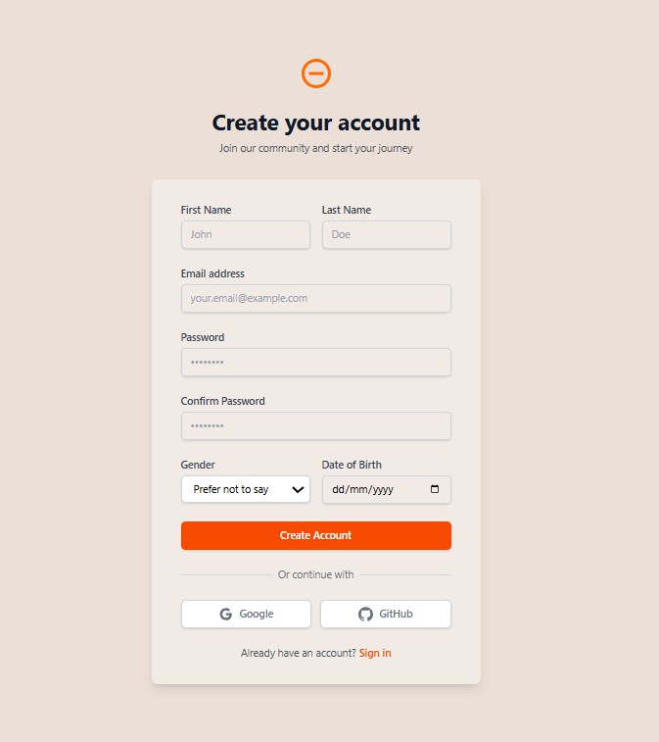
Figure 1: Signup Form
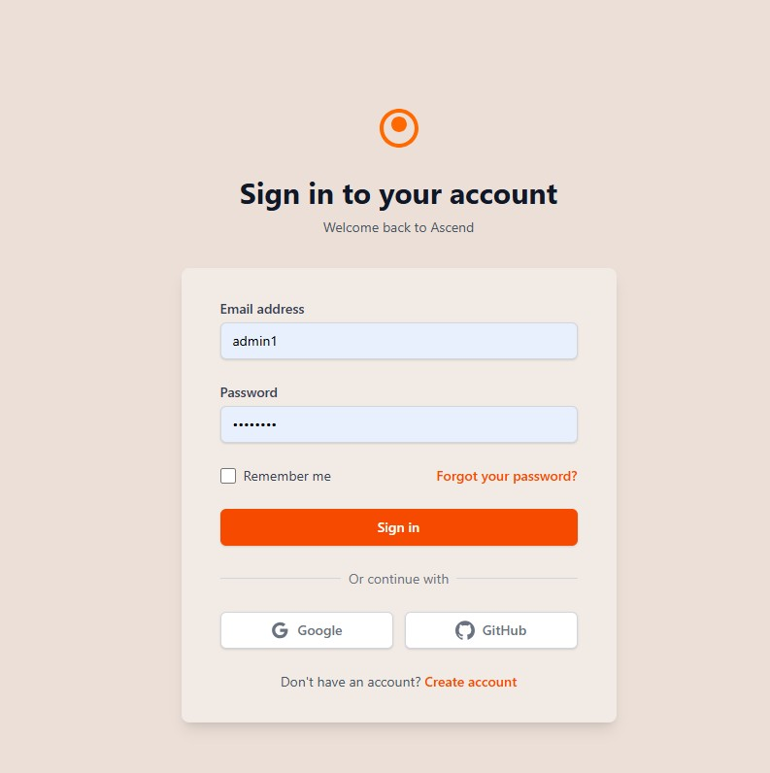
Figure 2: Login Form
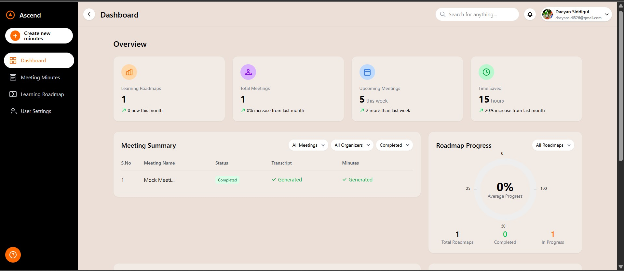
Figure 3: Dashboard
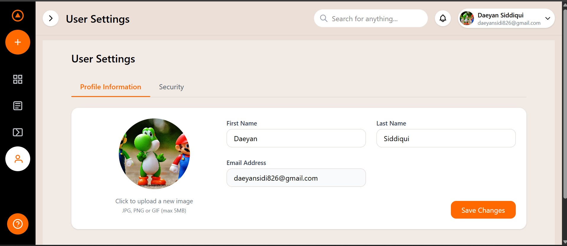
Figure 4: Profile
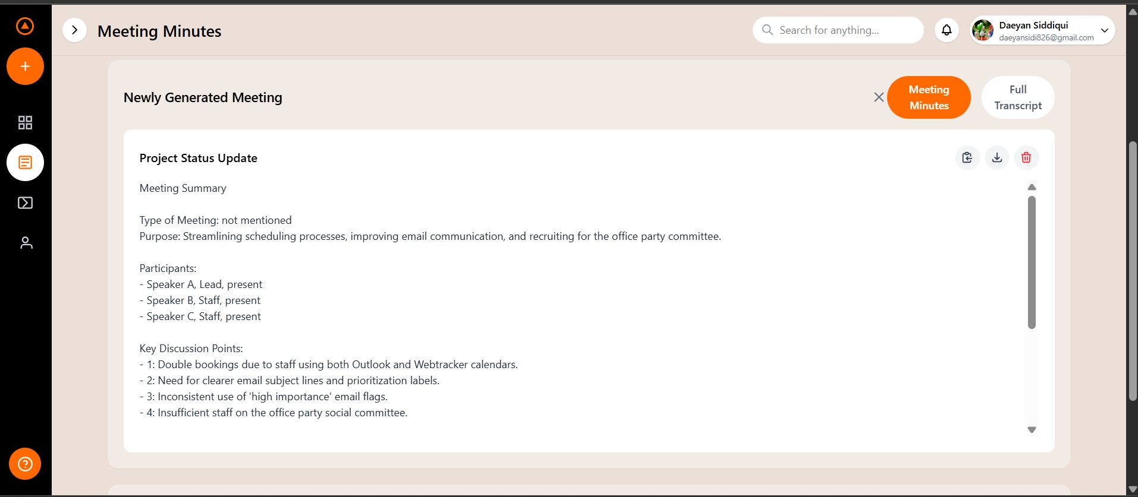
Figure 5: Summary
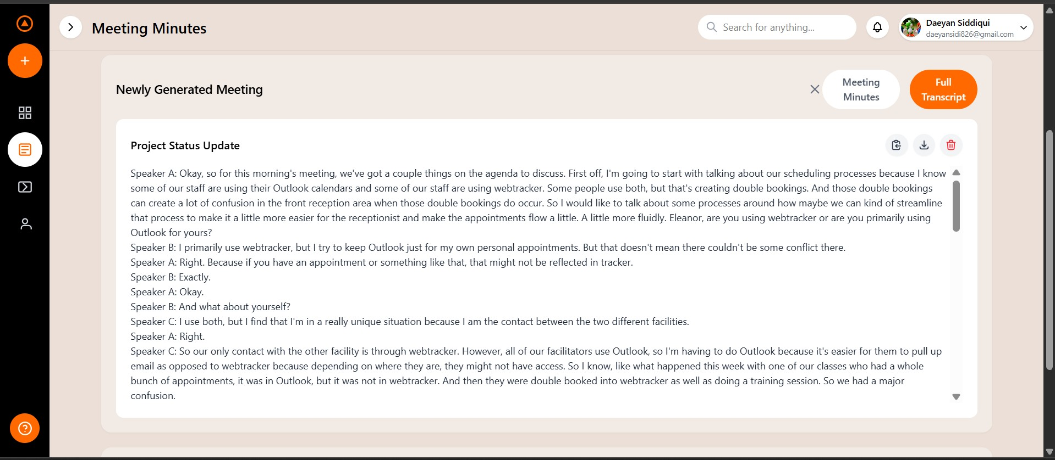
Figure 6: Transcript
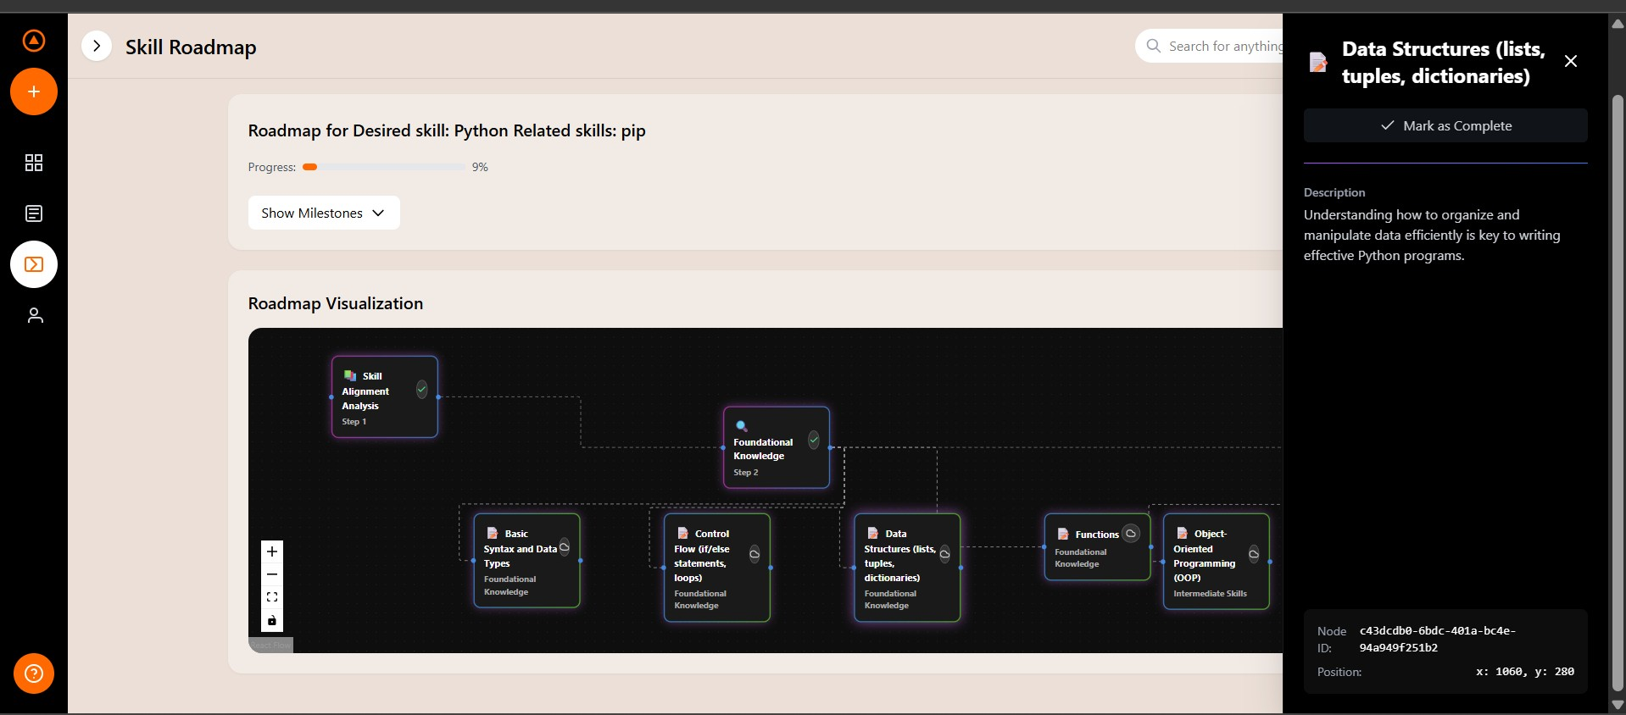
Figure 7: Roadmap

Databases
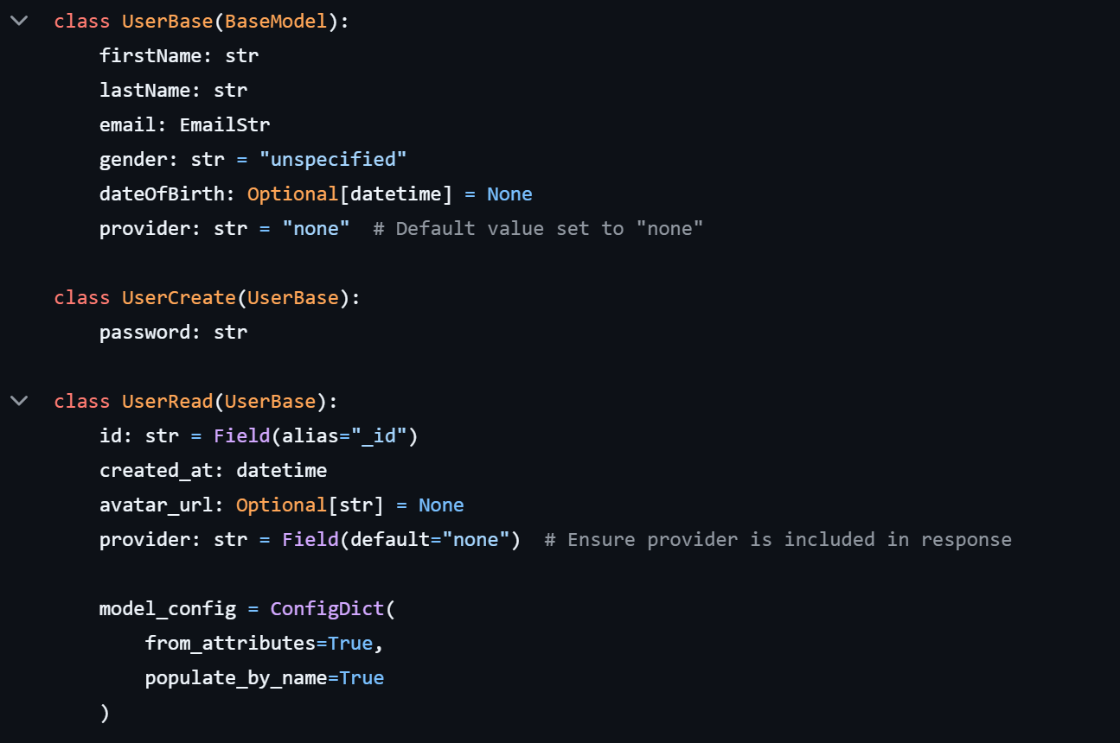
Figure 8: MongoDB User Schema Definition using Pydantic Models (Python)
This code defines the structure of user data stored in the MongoDB database using Pydantic models in Python. The UserBase class outlines common fields such as firstName, lastName, email, and gender, while the UserCreate model adds a password field specifically for user registration. The UserRead model is used for safely reading and returning user data from the database, including the unique _id (aliased as id) and a timestamp created_at. These models help enforce data validation, structure, and serialization for secure and consistent database interactions throughout the AscendPro platform.
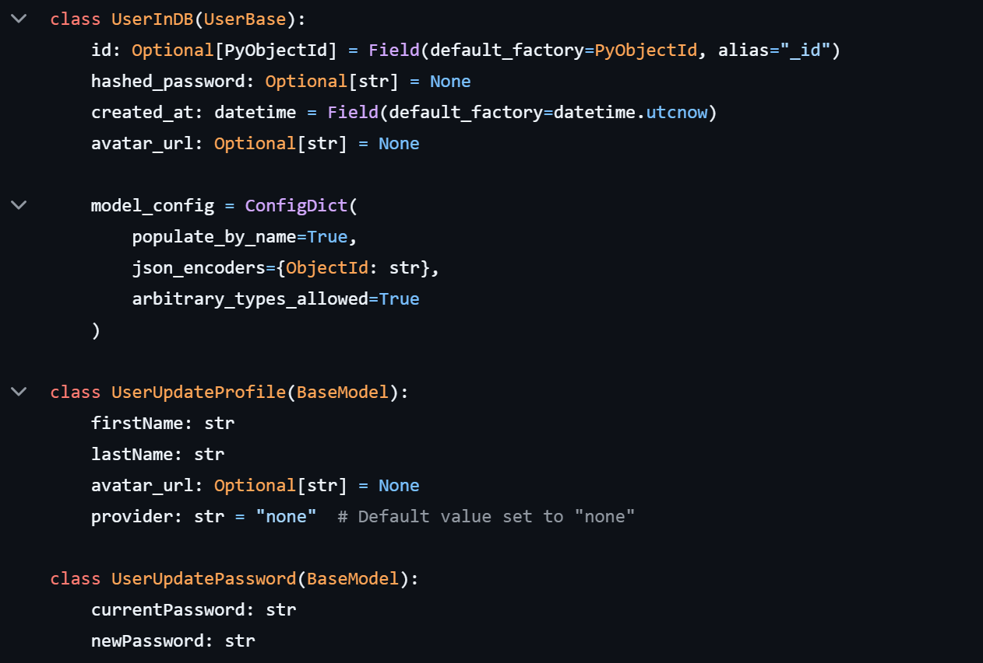
Figure 9: Extended MongoDB User Models for Storage and Updates
This snippet illustrates additional Pydantic models used for MongoDB storage and user profile updates in AscendPro. The UserInDB model extends UserBase and includes fields such as the internal _id, hashed_password, and created_at timestamp, enabling secure and structured storage of user data in the database. It uses json_encoders and custom ID handling (PyObjectId) to ensure MongoDB ObjectIds are properly serialized.
The UserUpdateProfile model allows users to safely update their personal information like name and avatar, while the UserUpdatePassword model handles password change requests by validating the current and new passwords. These models promote clean data updates and strict validation across all user related operations.

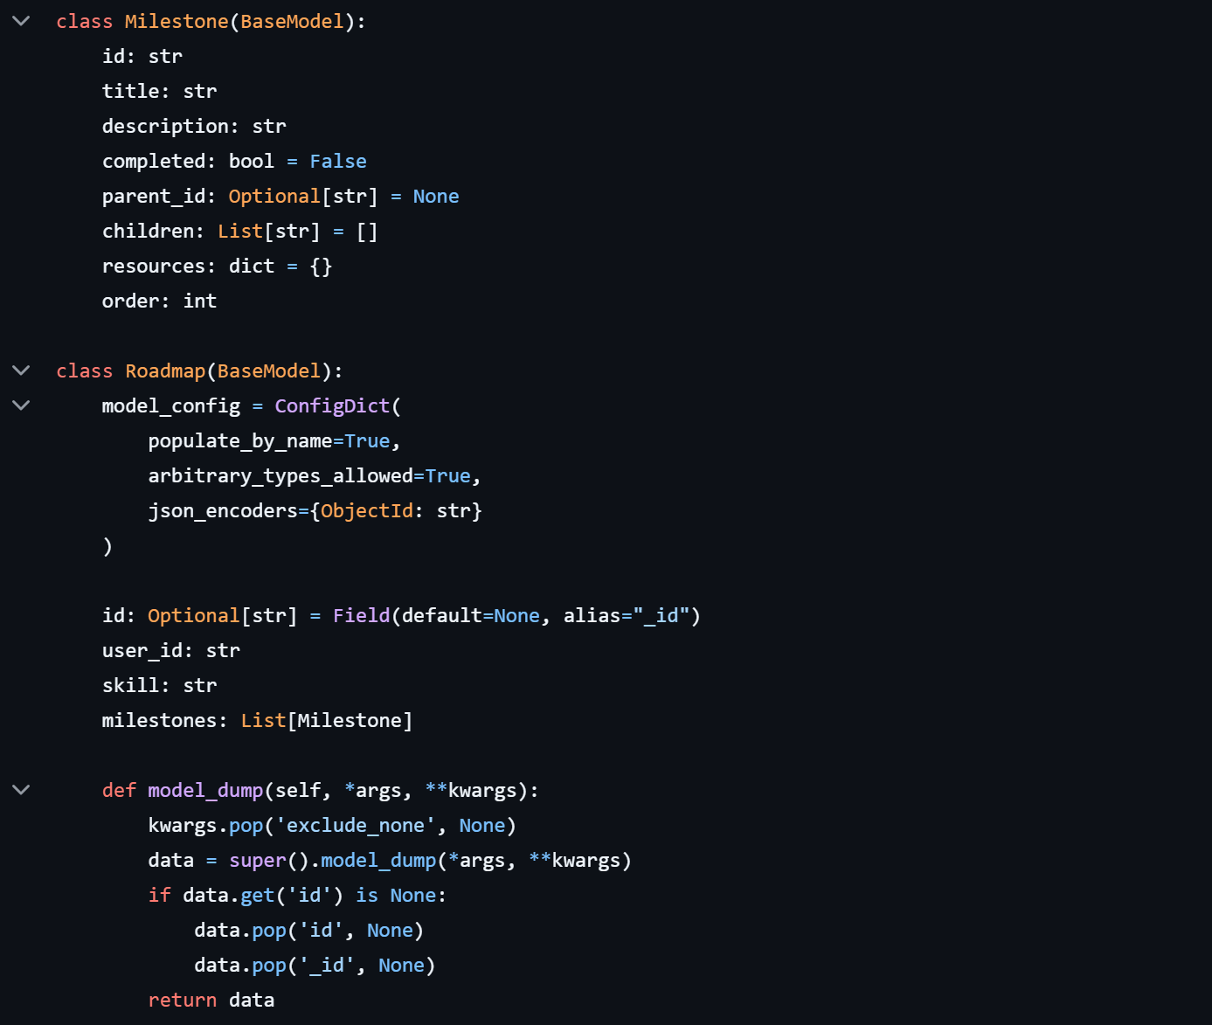
Figure 10: MongoDB Schema for Skill Development Roadmaps and Milestones
This code defines the data models for skill development roadmaps in AscendPro using Pydantic. The Milestone class represents individual steps in a user's learning journey. Each milestone includes a unique id, title, description, completion status, hierarchical relations (parent_id, children), associated learning resources, and a defined order to structure roadmap progression.
The Roadmap model groups related milestones under a specific skill and links them to a user via user_id. It features serialization logic to handle MongoDB ObjectIds and ensure clean JSON output when persisting or retrieving data. This structure allows the platform to deliver dynamic, personalized learning paths that evolve with user progress and career goals.
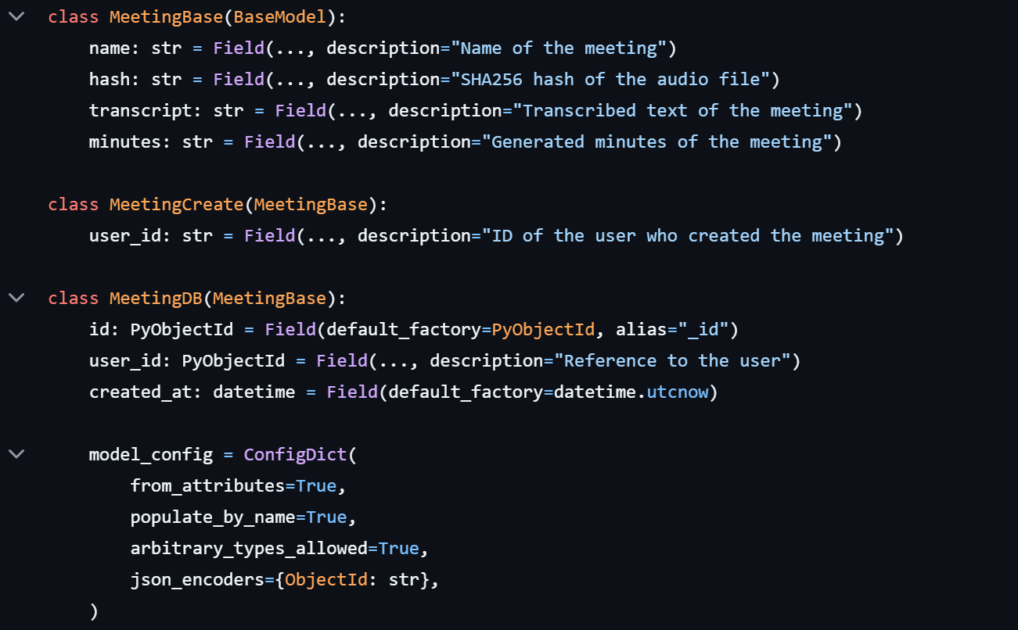
Figure 11: MongoDB Schema for Meeting Management and Transcription
This code defines the data models for storing and managing meeting related data in AscendPro. The MeetingBase model includes essential attributes such as the meeting name, a SHA256 hash of the uploaded audio file for integrity verification, the transcript generated from the audio, and the AI generated minutes summarizing the discussion.
The MeetingCreate model adds a user_id field to associate the meeting with the creator, while MeetingDB represents the complete structure stored in MongoDB. It includes a unique _id, the referenced user_id, and a created_at timestamp. These models ensure secure, consistent, and searchable storage of all meetings, enabling seamless access to past discussions and actionable insights through the platform’s meeting management features.

Findings
This chapter presents an analysis of key findings from the development and implementation of the AscendPro platform, including project cost, timeline adherence, unforeseen side effects, and residual risks that remain after mitigation strategies.

Cost
AscendPro was developed using a combination of open source technologies and freely available developer resources, which significantly reduced the overall financial burden. However, some costs were either incurred or projected, particularly due to API usage and hosting infrastructure.

Estimated Cost Breakdown:
Component | Description | Estimated Cost (USD)
Hosting and Domain | Server for backend (initial deployment) and custom domain | $0 (Free Tier)
OpenAI Whisper API (Free Tier Used) | For meeting transcription and summarization | $0 (Free Tier)
Google Gemini API (Limited Tier) | NLP capabilities | ~$5/month (scaled)
Miscellaneous Tools | Prototyping, testing, UI libraries | $0 (Figma Free, etc)
Total Estimated Monthly Expense |  | ~$5/month
Table 1: Estimated Cost Breakdown

Schedule
The project was organized across an 8 month timeline, divided into specific development phases. While the team mostly stayed within the planned schedule, minor delays occurred during the integration of complex APIs.
The planned and actual completion date for each milestone is shown in the Table 1: Milestones Completion

Milestone / Deliverable | Planned Completion | Actual Completion | Deviation (Days)
Project Planning and Research | Month 1 | Month 1 | 0
Requirement Gathering and Documentation | Month 2 | Month 2 | 0
UI/UX Design and Prototyping | Month 2.5 | Month 3 | +15
Frontend and Backend Development | Months 3–4 | Months 3–5 | +30
API Integration (AI Features) | Months 5–6 | Month 6 | 0
Testing and Refinement | Month 7 | Month 7 | 0
Final Documentation & Presentation | Month 8 | In Progress | N/A
Table 1: Milestones Completion

Key Observations:
- Frontend integration took longer due to redesign.
- The team effectively caught up by overlapping development and testing phases.

Side Effects
Although AscendPro achieved its primary goals, several unanticipated side effects were observed:

API Latency Issues
- Some third party AI services (especially during peak usage) showed high response times, affecting the smoothness of transcription.
Remediation: Implemented loading indicators and asynchronous queuing to improve user perception of performance.

Privacy Concerns by Testers
- During initial user testing, participants expressed concerns about recording live meetings and AI access to sensitive conversations.
Remediation: Added prominent consent prompts and manual upload option for meeting audio instead of always on recording.

Residual Risks
Despite thorough testing and mitigation efforts, a few residual risks remain that must be monitored in future deployments or product versions:

API Dependency Risk
- The platform’s core functionalities (transcription, summary, content recommendation) heavily rely on third party APIs.
  - Risk: API rate limits, pricing changes, or discontinuation.
  - Plan: Identify and test fallback APIs, cache critical results.

User Data Security
- While data encryption and secure authentication are in place, storing sensitive meeting content remains a high risk factor.
  - Risk: Data breach or unauthorized access.
  - Plan: Periodic security audits, user controlled data deletion options.

Regulatory Compliance
- Future expansion to international markets (e.g., Europe, US) may trigger compliance requirements under GDPR, CCPA, or HIPAA.
  - Risk: Legal issues or platform bans.
  - Plan: Build compliance modules and consult legal advisors when scaling.

Chapter 4
Conclusions and Future Work

4.1 Conclusions
AscendPro represents a novel and forward thinking approach to employee productivity, professional development, and interpersonal communication within organizational environments. By integrating Artificial Intelligence with modern web technologies, the platform successfully addresses three major challenges in the workplace:
- Meeting Management , The system automates note taking, provides real time transcription, and generates summaries, allowing employees to focus on meaningful discussions rather than administrative tasks.
- Skill Development , With personalized roadmaps and intelligent content recommendations, users can clearly visualize their career paths, set development goals, and access relevant learning materials, all within a unified interface.
The project was implemented using a modern and scalable tech stack (React.js, Next.js, Python, MongoDB) and leveraged state of the art APIs (OpenAI Whisper, Google Gemini) to power AI capabilities. Despite facing challenges such as API limitations, ethical concerns, and delays in UI integration, the development team successfully created a working prototype that met the defined objectives within the academic timeline.
AscendPro is not just a technical solution, it is a vision of a more adaptive, AI augmented workplace that puts employee growth and communication at the center of organizational success.

4.2 Recommendation in Future Work
While the current version of AscendPro lays a solid foundation, several areas have been identified for enhancement and expansion in future iterations:

1. Native Mobile Applications
- Develop dedicated Android and iOS apps for improved accessibility.
- Use cross platform frameworks like React Native or Flutter.

2. Advanced Analytics and Reporting
- Introduce AI driven insights to identify behavioral patterns in meetings.
- Provide managerial dashboards for team wide skill tracking and meeting performance.

3. Integration with Enterprise Tools
- Allow integration with third party tools like Microsoft Teams, Slack, Zoom, Trello, or Google Calendar for seamless workflow connectivity.

4. Multilingual Support
- Expand language support in transcription, summaries, and UI to cater to global users.

5. AI Model Improvement
- Fine tune models using reinforcement learning based on user feedback.
- Incorporate emotional intelligence and tone detection during simulations.

6. Compliance and Legal Modules
- Add modules that guide organizations in data compliance (GDPR, CCPA) and audit logging.
- Provide role based data access for compliance officers.

7. Community and Content Ecosystem
- Allow organizations to upload custom training materials.
- Create a content sharing marketplace where users can rate, review, and recommend skill building content.

8. Offline Features
- Enable offline note taking or roadmap access for users with limited internet access, syncing data once connected.

9. AI Coaching Assistant
- Introduce a real time AI assistant that guides users through meetings or skills using chat or voice interaction.
These future enhancements will further strengthen the impact and utility of AscendPro in diverse organizational contexts and make it a comprehensive platform for intelligent workforce enablement.

References
[1] Arakawa, Riku, et al. "AI for Meeting Minutes: Promises and Challenges in Designing Human-AI Collaboration on a Production SaaS Platform." Proceedings of the Extended Abstracts of the CHI Conference on Human Factors in Computing Systems. 2025.
[2] Reim, Wiebke, Josef Åström, and Oliver Eriksson. "Implementation of artificial intelligence (AI): a roadmap for business model innovation." Ai 1.2 (2020): 11.
[3] Khare, Pranav, Sahil Arora, and Sandeep Gupta. "Integration of Artificial Intelligence (AI) and Machine Learning (ML) into Product Roadmap Planning." 2024 First International Conference on Electronics, Communication and Signal Processing (ICECSP). IEEE, 2024.
[4] Pandita, Karan, Purab Kulranjan Singh Thakur, and Suresh Annamalai. "Contextual transcription and Summarization of audio using AI." Proceedings of the 5th International Conference on Information Management & Machine Intelligence. 2023.
[5] Herdiyanti, Anisah. "The Use of Automatic AI-based Notes and Transcription Services in Qualitative Research: Ethical and Methodological Concerns." Proceedings of the ALISE Annual Conference. 2024.
[6] Tomar, Suramya. "Converting video formats with FFmpeg." Linux journal 2006.146 (2006): 10.
[7] Mallika, Rika, and Mrinal Bachute. "Speech subscribers using Python." IET Conference Proceedings CP859. Vol. 2023. No. 44. Stevenage, UK: The Institution of Engineering and Technology, 2023.
[8] Team, Gemini, et al. "Gemini 1.5: Unlocking multimodal understanding across millions of tokens of context." arXiv preprint arXiv:2403.05530 (2024).
[9] Anguera, Xavier, et al. "Speaker diarization: A review of recent research." IEEE Transactions on audio, speech, and language processing 20.2 (2012): 356-370.
[10] Kinnunen, Tomi, Evgeny Karpov, and Pasi Franti. "Real-time speaker identification and verification." IEEE Transactions on Audio, Speech, and Language Processing 14.1 (2005): 277-288.
[11] Theodorou, Theodoros, Iosif Mporas, and Nikos Fakotakis. "An overview of automatic audio segmentation." International Journal of Information Technology and Computer Science (IJITCS) 6.11 (2014): 1.
[12] Wu, Xiaomin. "FastAPI as a backend framework." (2024).
[13] Lee, Linda W., et al. "Making sense of text: artificial intelligence-enabled content analysis." European Journal of Marketing 54.3 (2020): 615-644.

Appendix
Appendix A: Glossary
Term | Definition
AI (Artificial Intelligence) | The simulation of human intelligence processes by machines, especially computer systems, including learning, reasoning, and self correction.
API (Application Programming Interface) | A set of protocols and tools for building software applications, allowing different systems to communicate and share data.
NLP (Natural Language Processing) | A field of AI focused on the interaction between computers and humans using natural language, enabling tasks like transcription and summarization.
MongoDB | A NoSQL, document oriented database used for storing data in flexible, JSON like formats, suitable for dynamic and scalable applications.
Pydantic | A Python library used for data validation and settings management using Python type annotations, commonly used with FastAPI.
Skill Roadmap | A personalized plan outlining the learning milestones and resources needed for a user to develop a particular skill.
Transcription | The process of converting spoken audio into written text, typically performed using AI models such as OpenAI Whisper.
Meeting Summarization | The AI powered process of generating a concise, structured summary of a meeting, highlighting key points and action items.
Frontend | The part of a web application that users interact with, typically built with technologies like HTML, CSS, JavaScript, React.js, or Next.js.
Backend | The server side logic of an application, handling data storage, processing, and API integration, built here using Python.
ObjectId | A special 12 byte identifier used by MongoDB to uniquely identify documents.
OAuth 2.0 | An authorization framework that allows third party applications to access user resources without exposing their credentials.
GDPR (General Data Protection Regulation) | A regulation in EU law that governs how personal data should be handled and protected.
CCPA (California Consumer Privacy Act) | A state law that provides data privacy rights to California residents regarding how their personal data is collected and used.
REST API | A set of web service principles using HTTP methods to interact with resources, often used for building scalable and stateless services.
ConfigDict | A configuration class used in Pydantic models for advanced behavior such as field population and type handling.
Field() | A function in Pydantic used to define metadata and validation rules for model attributes.
JSON Encoder | A method or configuration used to convert non standard types (e.g., ObjectId) into JSON serializable formats.
Table 3: Glossary
Appendix B: Analysis Models
B.1 Data Models
The AscendPro platform utilizes several data models to manage and organize information related to users, meetings, and skill development roadmaps. Below are the detailed descriptions of each primary data model, including their attributes and relationships.
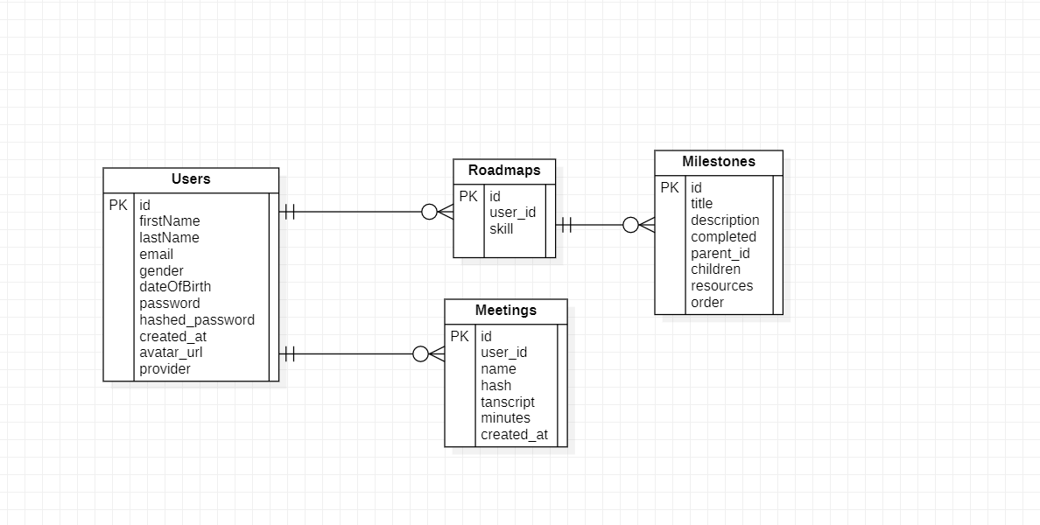
Figure 12: Data Model
B.2 Data Flow Diagrams
B.2.1 Level 0: Context Diagram
Description: The Context Diagram provides a high level overview of the AscendPro system, illustrating its interactions with external entities.
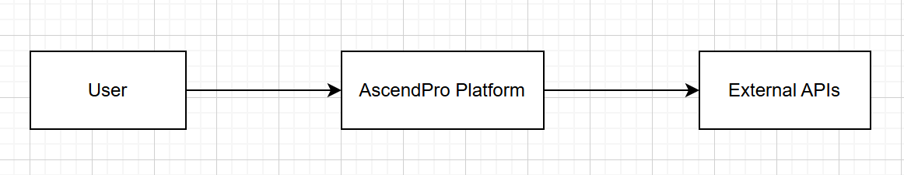
Figure 13: Context Diagram
Components:
- User: Interacts with the AscendPro platform to manage meetings and develop skills.
- External APIs: Provide AI powered services such as audio analysis, and skill recommendations.
- AscendPro Platform: Central system handling meeting management and employee development functionalities.
B.2.2 Level 1: Data Flow Diagram
Description: The Level 1 Data Flow Diagram breaks down the main processes within the AscendPro platform, detailing how data flows between different modules and external entities.
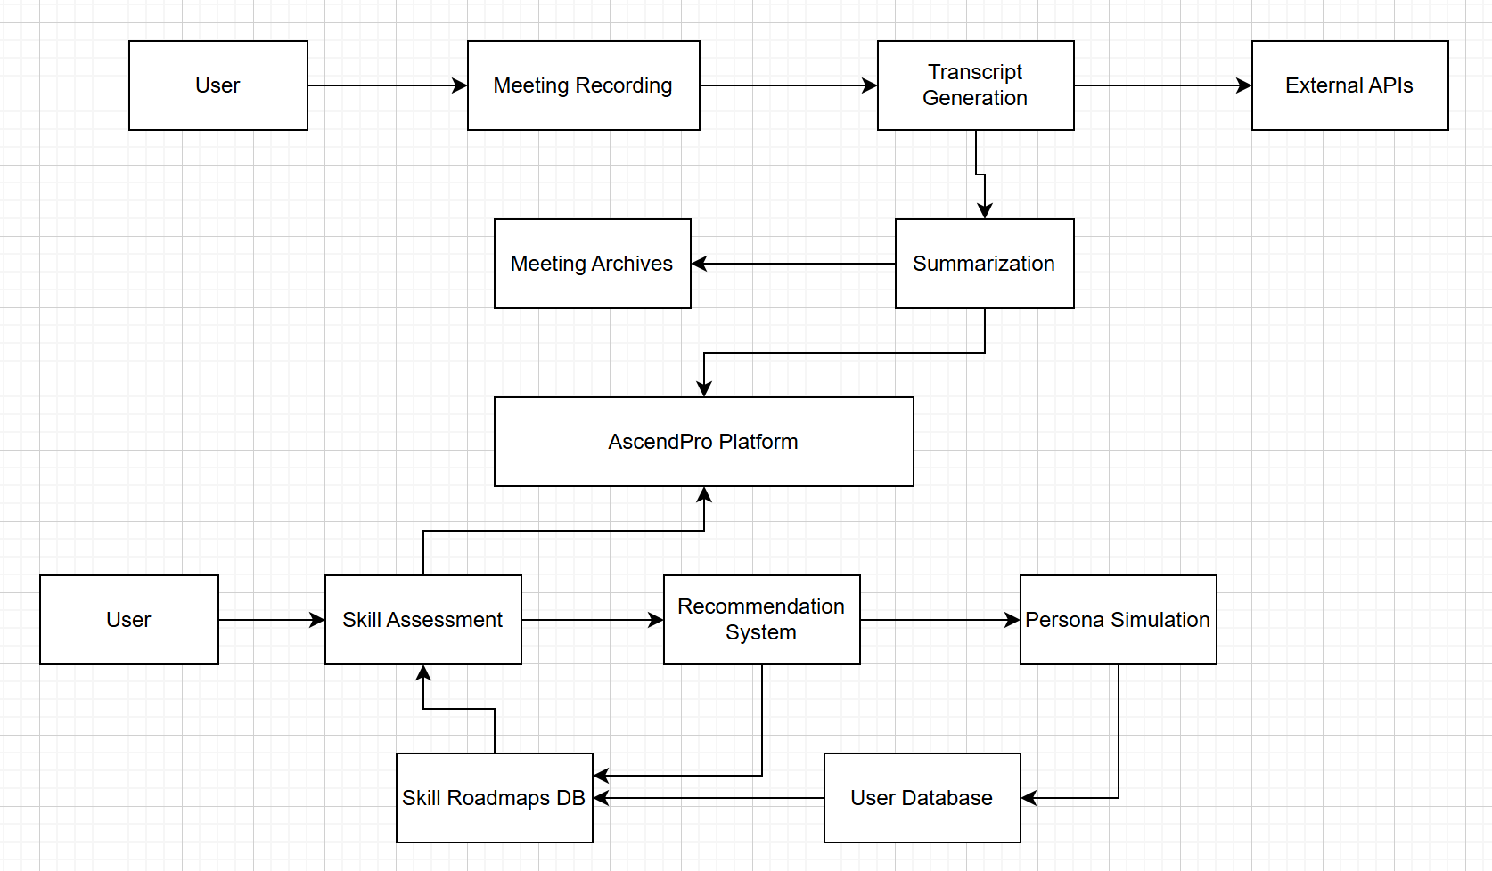
Figure 14: Data Flow Diagram
Processes:
- Meeting Management:
  - Meeting Recording: Captures audio from meetings.
  - Transcript Generation: Sends audio to External APIs for transcription.
  - Summarization: Generates meeting minutes from transcripts.
- Employee Development Tools:
  - Skill Assessment: Evaluates user skills using AI driven assessments.
  - Recommendation System: Provides personalized skill roadmaps and content suggestions.
Data Stores:
- User Database: Stores user profiles, authentication details, and preferences.
- Meeting Archives: Stores meeting recordings, transcripts, and summaries.
- Skill Roadmaps Database: Stores users' skill development plans and milestones.
B.3 Entity Relationship Diagrams (ERD)
Figure 15: ERD
B.3.1 User and Meeting Relationship
Relationship:
- One to Many: A User can create multiple Meetings, but each Meeting is associated with only one User.
B.3.2 User and Roadmap Relationship
Relationship:
- One to Many: A User can have multiple Roadmaps for different skills, but each Roadmap is linked to one User.
B.3.3 Roadmap and Milestone Relationship
Relationship:
- One to Many (Hierarchical): A Roadmap consists of multiple Milestones. Milestones can have parent child relationships to represent dependencies or sequential steps.
B.4 Class Diagrams
B.4.1 User Class and Meeting Classes
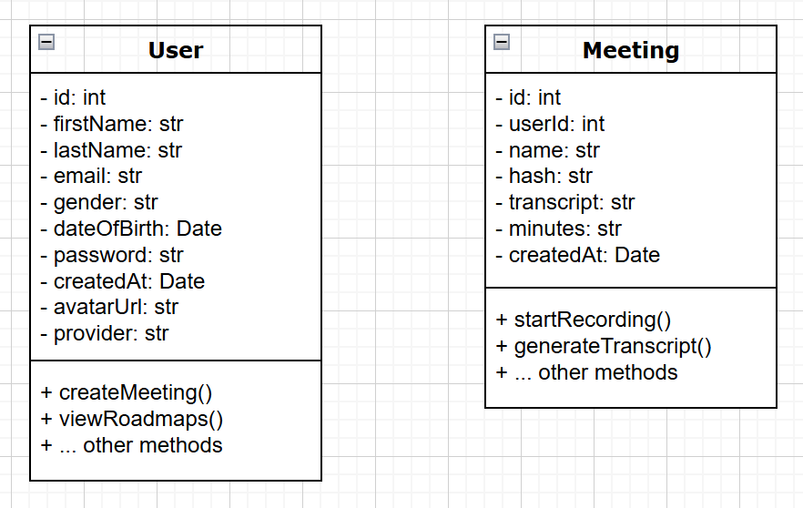
Figure 16: User and Meeting Classes

B.4.2 Roadmap and Milestone Classes
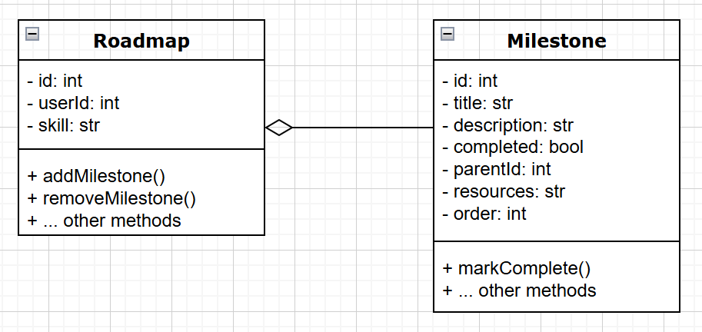
Figure 17: Roadmap and Milestone Classes
Notes:
- The Roadmap class aggregates multiple Milestone instances.
- The <>------ notation indicates aggregation, where a Roadmap is composed of multiple Milestones.
B.5 Sequence Diagrams
B.5.1 Creating a Meeting
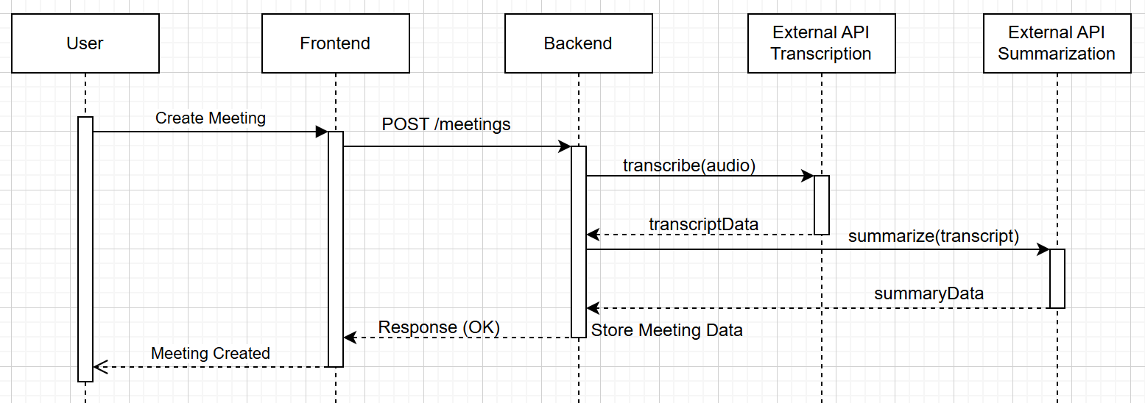
Figure 18: Creating a Meeting
Steps:
- User initiates the creation of a meeting via the Frontend.
- Frontend sends a POST request to the Backend to create the meeting.
- Backend calls the External API to transcribe the meeting audio.
- External API returns the transcript data to the Backend.
- Backend summarizes the meeting using another External API.
- External API returns the summary data.
- Backend stores the meeting details and responds with a confirmation to the Frontend.
- Frontend notifies the User of the successful creation of the meeting.

B.5.2 Generating a Skill Roadmap
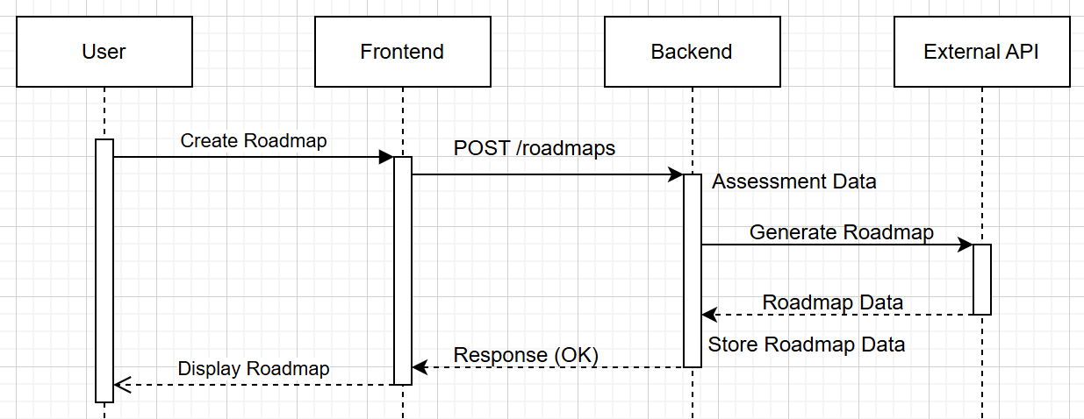
Figure 19: Generating a Skill Roadmap
Steps:
- User requests the generation of a skill roadmap via the Frontend.
- Frontend sends a POST request to the Backend to create the roadmap.
- Backend assesses the user's current skills.
- Backend generates a personalized roadmap using the assessment data via the External API.
- External API returns the roadmap data.
- Backend stores the roadmap and responds with a confirmation to the Frontend.
- Frontend displays the newly created roadmap to the User.

Appendix C: To Be Determined List
The following items are identified as needing further clarification, development, or decision making to complete the AscendPro platform's design and implementation. Addressing these items will ensure a comprehensive and robust system that meets all user and business requirements.
C.1 Functional Requirements
Mobile Application Development
- Determine the scope and features for native mobile applications on iOS and Android platforms.
- Decide whether to develop separate apps or use a cross platform framework.
Advanced Reporting Features
- Define the specific metrics and analytics to be included in user and administrative reports.
- Establish customizable reporting options for different user roles.
Integration with Additional Enterprise Tools
- Identify other enterprise software (e.g., Microsoft Teams, Slack, Zoom) for potential integration.
- Define the integration workflows and data synchronization methods.
Multilingual Support
- Determine the languages to be supported initially and plan for future additions.
- Establish a localization strategy for UI elements, content recommendations, and documentation.
C.2 Technical Requirements
API Endpoint Specifications
- Finalize the detailed specifications for all backend API endpoints.
- Define request and response formats, authentication mechanisms, and error handling procedures.
Scalability Strategies
- Decide on specific scalability solutions, such as containerization, microservices architecture, or serverless deployments.
- Plan for horizontal and vertical scaling based on projected user growth.
Performance Benchmarks
- Establish detailed performance benchmarks for various system components, including response times, throughput, and resource utilization.
Define acceptable performance thresholds and monitoring strategies.
Data Backup and Recovery Procedures
- Develop comprehensive data backup schedules and recovery plans.
- Determine the tools and technologies to be used for automated backups and disaster recovery.
C.3 Security Requirements
Multi Factor Authentication (MFA) Implementation
- Decide on the types of MFA to be supported (e.g., SMS, authenticator apps, hardware tokens).
- Define the user experience and fallback options for MFA processes.
Advanced Encryption Standards
- Determine additional encryption methods for sensitive data beyond TLS and AES 256.
- Plan for encryption key management and rotation policies.
Compliance with Additional Regulations
- Identify other relevant data protection regulations based on target markets (e.g., HIPAA, CCPA).
- Develop strategies to ensure ongoing compliance with evolving legal requirements.
C.4 User Interface and Experience
Final UI/UX Design Elements
- Complete the design of all user interface components, ensuring consistency and accessibility.
- Conduct user testing to gather feedback and make necessary adjustments.
Accessibility Enhancements
- Implement advanced accessibility features to support users with disabilities.
- Ensure compliance with all relevant accessibility standards (e.g., WCAG 2.1).
User Personalization Options
- Define the extent of user customization available within the platform (e.g., dashboard widgets, notification preferences).
- Develop personalization algorithms to enhance user experience based on behavior and preferences.
C.5 Content and Resource Management
Content Recommendation Sources
- Identify and curate the sources for courses, articles, and training materials used in content recommendations.
- Establish partnerships or licensing agreements with content providers as needed.
Dynamic Content Updating
- Develop mechanisms for regularly updating and refreshing recommended content to ensure relevance.
- Implement user feedback loops to refine content suggestions continuously.
C.6 Testing and Quality Assurance
Comprehensive Testing Plans
- Develop detailed testing strategies, including unit tests, integration tests, system tests, and user acceptance tests.
- Define testing tools and frameworks to be used throughout the development lifecycle.
Automated Testing Pipelines
- Set up continuous integration and continuous deployment (CI/CD) pipelines with automated testing stages.
- Ensure that all code changes are automatically tested before deployment.
C.7 Deployment and Maintenance
Deployment Strategies
- Decide on the cloud infrastructure and services (e.g., AWS, Azure, Google Cloud) for hosting the platform.
- Plan for automated deployment processes to ensure smooth rollouts and updates.
Maintenance Schedules
- Establish regular maintenance windows for system updates, patches, and performance optimizations.
- Develop monitoring and alerting systems to proactively address issues.
C.8 User Training and Support
Comprehensive Training Programs
- Design training modules and materials to help users effectively utilize all platform features.
- Plan for onboarding sessions, webinars, and workshops as needed.
Support Infrastructure
- Define the support channels available to users (e.g., live chat, email support, knowledge base).
- Establish response time targets and support quality standards.
C.9 Future Enhancements
AI Model Enhancements
- Plan for the continuous improvement of AI models used for audio analysis, and skill recommendations.
- Explore the integration of advanced machine learning techniques to enhance feature capabilities.
Feature Expansion
- Identify potential new features based on user feedback and market trends.
- Prioritize feature development to align with strategic business goals.
Appendix D: Source Code
D.1 Services
Minutes Service
# AI/services/minutes_service.py

import google.generativeai as genai
from google.generativeai.types import HarmCategory, HarmBlockThreshold
from AI.logger import logger
from AI.config import GOOGLE_API_KEY

def generate_minutes(transcript_text: str, system_prompt: str) -> str:
"""
Generates minutes of the meeting using Google Generative AI.
"""
try:
genai.configure(api_key=GOOGLE_API_KEY)
generation_config = {
"temperature": 0,
"top_p": 0.1,
"top_k": 1,
"max_output_tokens": 8192,
"response_mime_type": "text/plain",
}
model = genai.GenerativeModel(
model_name="gemini-1.5-flash",
generation_config=generation_config,
system_instruction=system_prompt,
)
logger.info("Generating minutes of the meeting...")
response = model.generate_content(
[transcript_text],
safety_settings={
HarmCategory.HARM_CATEGORY_HATE_SPEECH: HarmBlockThreshold.BLOCK_NONE,
HarmCategory.HARM_CATEGORY_HARASSMENT: HarmBlockThreshold.BLOCK_NONE,
HarmCategory.HARM_CATEGORY_SEXUALLY_EXPLICIT: HarmBlockThreshold.BLOCK_NONE,
HarmCategory.HARM_CATEGORY_DANGEROUS_CONTENT: HarmBlockThreshold.BLOCK_NONE,
}
)
logger.info("Minutes of the meeting generated successfully.")
return response.text.strip()
except Exception as e:
logger.error(f"Failed to generate minutes of the meeting: {e}")
raise
Roadmap Service
import google.generativeai as genai
from google.generativeai.types import HarmCategory, HarmBlockThreshold
from AI.logger import logger
from AI.config import GOOGLE_API_KEY
import re
import uuid
from AI.models.roadmap import Milestone, Roadmap
from AI.db import create_roadmap
import json
import os
from datetime import datetime

def generate_roadmap(project_requirements: str, system_prompt: str, user_id: str) -> Roadmap:
"""
Generates project roadmap based on provided requirements using Google Generative AI.
"""
try:
genai.configure(api_key=GOOGLE_API_KEY)
generation_config = {
"temperature": 0,
"top_p": 0.1,
"top_k": 1,
"max_output_tokens": 8192,
"response_mime_type": "text/plain",
}
model = genai.GenerativeModel(
model_name="gemini-1.5-flash",
generation_config=generation_config,
system_instruction=system_prompt,
)
logger.info("Generating project roadmap...")
response = model.generate_content([project_requirements])
raw_text = response.text

# Save raw response
raw_path = save_raw_response(raw_text, user_id)

# Clean and validate response
cleaned_text = clean_response_text(raw_text)
cleaned_path = save_cleaned_response(cleaned_text, user_id)

# Parse cleaned response
roadmap = parse_roadmap_text(cleaned_text, user_id, project_requirements)

# Save to database and get ID
roadmap_dict = roadmap.model_dump()
roadmap_id = create_roadmap(roadmap_dict)
roadmap.id = roadmap_id

return roadmap

except Exception as e:
logger.error(f"Error generating roadmap for user {user_id}: {str(e)}")
raise

def parse_roadmap_text(text: str, user_id: str, desired_skill: str) -> Roadmap:
"""Parse roadmap text and create milestone structure"""
try:
response_data = json.loads(text)
roadmap_content = response_data["personalized_learning_roadmap"]
milestones = []

def create_milestone(title: str, description: str, parent_id: str = None, order: int = 0) -> str:
"""Helper function to create milestone objects"""
milestone_id = str(uuid.uuid4())
milestone = Milestone(
id=milestone_id,
title=title,
description=description,
parent_id=parent_id,
order=order,
completed=False,
children=[]
)
milestones.append(milestone)
return milestone_id

def format_section_description(section_data: dict) -> str:
"""Format section description with action items and resources"""
description = ""
if "action_items" in section_data:
description += "Action Items:\n" + "\n".join(f"- {item}" for item in section_data["action_items"])
if "recommended_resources" in section_data:
description += format_resources(section_data["recommended_resources"])
return description.strip()

# Define all sections in order
sections = [
("skill_alignment_analysis", "Skill Alignment Analysis"),
("foundational_knowledge", "Foundational Knowledge"),
("intermediate_skills", "Intermediate Skills"),
("advanced_mastery", "Advanced Mastery"),
("practical_application", "Practical Application"),
("community_engagement", "Community Engagement")
]

# Process each section
for order, (section_key, section_title) in enumerate(sections):
if section_key == "skill_alignment_analysis" and section_key in roadmap_content:
alignment = roadmap_content[section_key]
description = (
"Required Foundations:\n" +
"\n".join(f"- {f}" for f in alignment["existing_or_inferred_foundations"]) +
f"\n\nAnalysis:\n{alignment['analysis']}"
)
create_milestone(title=section_title, description=description, order=order)

elif section_key == "community_engagement" and "practical_application" in roadmap_content:
if "community_engagement" in roadmap_content["practical_application"]:
parent_id = create_milestone(
title=section_title,
description="Platforms and communities for continuous learning",
order=order
)
for idx, item in enumerate(roadmap_content["practical_application"]["community_engagement"]):
create_milestone(
title=item["platform"],
description=item["description"],
parent_id=parent_id,
order=idx
)

elif section_key in roadmap_content:
section_data = roadmap_content[section_key]
parent_id = create_milestone(
title=section_title,
description=format_section_description(section_data),
order=order
)

if "objectives" in section_data:
for idx, obj in enumerate(section_data["objectives"]):
create_milestone(
title=obj.get("topic", obj.get("application", "")),
description=obj["description"],
parent_id=parent_id,
order=idx
)

return Roadmap(
user_id=user_id,
skill=desired_skill,
milestones=milestones
)

except Exception as e:
logger.error(f"Error processing roadmap: {str(e)}")
logger.error(f"Data received: {text[:200]}...")
raise

def save_raw_response(response_text: str, user_id: str):
"""Save raw response to logs directory"""
logs_dir = os.path.join(os.path.dirname(__file__), '..', 'logs', 'raw_responses')
os.makedirs(logs_dir, exist_ok=True) # Fixed parameter name

timestamp = datetime.now().strftime('%Y%m%d_%H%M%S')
filename = f"response_{user_id}_{timestamp}.json"
filepath = os.path.join(logs_dir, filename)

with open(filepath, 'w', encoding='utf-8') as f:
f.write(response_text)

logger.info(f"Raw response saved to: {filepath}")
return filepath

def save_cleaned_response(cleaned_text: str, user_id: str):
"""Save cleaned response to logs directory"""
logs_dir = os.path.join(os.path.dirname(__file__), '..', 'logs', 'cleaned_responses')
os.makedirs(logs_dir, exist_ok=True) # Fixed parameter name

timestamp = datetime.now().strftime('%Y%m%d_%H%M%S')
filename = f"cleaned_response_{user_id}_{timestamp}.json"
filepath = os.path.join(logs_dir, filename)

with open(filepath, 'w', encoding='utf-8') as f:
f.write(cleaned_text)

logger.info(f"Cleaned response saved to: {filepath}")
return filepath

def format_parent_description(section_data: dict) -> str:
"""Formats parent node description with action items and resources"""
description = []

# Add action items if present
if "action_items" in section_data and section_data["action_items"]:
description.append("Action Items:\n" +
"\n".join(f"- {item}" for item in section_data["action_items"]))

# Add resources if present and not empty
if "recommended_resources" in section_data:
resources_text = format_resources(section_data["recommended_resources"])
if resources_text:
description.append(resources_text)

# Return joined description or default text
if description:
return "\n\n".join(description)
return "Apply your skills through practical exercises and real-world projects."

def clean_response_text(text: str) -> str:
"""Remove markdown code blocks and clean JSON response"""
# Remove markdown code blocks
text = re.sub(r'^```json\s*', '', text)
text = re.sub(r'\s*```$', '', text)
text is text.strip()

try:
# Validate JSON by parsing and re-serializing
parsed = json.loads(text)
return json.dumps(parsed, indent=2)
except json.JSONDecodeError as e:
logger.error(f"Invalid JSON after cleaning: {str(e)}")
raise

def format_section_data(section_data: dict, parent_title: str) -> dict:
"""Helper to format section data with proper parent/child structure"""
formatted = {
"title": parent_title,
"content": []
}

if isinstance(section_data, list):
formatted["content"] = section_data
else:
for key, value in section_data.items():
if isinstance(value, list):
formatted["content"].extend(value)
else:
formatted["content"].append({
"type": key,
"data": value
})

return formatted

def format_roadmap_response(response_data: dict) -> dict:
"""Format roadmap response with proper node structure"""
formatted = {
"personalized_learning_roadmap": {
"desired_skill": response_data.get("desired_skill", ""),
"sections": []
}
}

# Add skill alignment analysis
if "skill_alignment_analysis" in response_data:
formatted["personalized_learning_roadmap"]["sections"].append({
"skill_alignment": format_section_data(
response_data["skill_alignment_analysis"],
"Skill Alignment Analysis"
)
})

# Add community engagement under parent node
if "community_engagement" in response_data:
formatted["personalized_learning_roadmap"]["sections"].append({
"community_engagement": format_section_data(
response_data["community_engagement"],
"Community Engagement"
)
})

return formatted

def format_resources(resources: dict) -> str:
"""Format recommended resources, skipping empty sections"""
if not resources:
return ""

resource_content = []
resource_types = {
"courses": "Courses",
"books": "Books",
"articles": "Articles"
}

# Gather non-empty sections
for key, title in resource_types.items():
if key in resources and resources[key] and len(resources[key]) > 0:
resource_content.append(f"{title}:\n" +
"\n".join(f"- {item}" for item in resources[key]))

# Return formatted resources if any exist
if resource_content:
return "Recommended Resources:\n\n" + "\n\n".join(resource_content)
return ""
Transcription Service
# AI/services/transcription_service.py

import assemblyai as aai
from AI.config import ASSEMBLYAI_API_KEY
from AI.logger import logger
import os

def transcribe_audio(file_path=None, url=None, config=None):
"""
Transcribes the given audio file using AssemblyAI.
"""
try:
aai.settings.api_key = ASSEMBLYAI_API_KEY
transcriber = aai.Transcriber()
if file_path and os.path.isfile(file_path):
logger.info(f"Starting transcription for local file: {file_path}")
transcript_result = transcriber.transcribe(file_path, config=config)
else:
logger.error("Invalid file path provided for transcription.")
raise ValueError("Invalid file path for transcription.")
logger.info("Transcription completed successfully.")
return transcript_result
except Exception as e:
logger.error(f"Failed to transcribe audio: {e}")
raise
d.2 Tests
Database Operations Test
# tests/test_db_operations.py

import pytest
from AI.db import (
get_meetings_by_user,
count_user_meetings,
upsert_meeting,
get_meeting_by_hash_and_user
)

def test_meeting_operations():
# Test data
test_user_id = "test_user_123"
test_meeting = {
"hash": "test_hash_456",
"user_id": test_user_id,
"name": "Test Meeting",
"transcript": "Test transcript",
"minutes": "Test minutes"
}

try:
# 1. Insert test meeting
upsert_meeting(test_meeting)

# 2. Verify retrieval by hash and user
retrieved_meeting = get_meeting_by_hash_and_user(test_meeting["hash"], test_user_id)
assert retrieved_meeting is not None
assert retrieved_meeting["name"] == "Test Meeting"

# 3. Verify all meetings for user
meetings = get_meetings_by_user(test_user_id)
assert len(meetings) > 0
assert any(m["hash"] == test_meeting["hash"] for m in meetings)

# 4. Verify meeting count
count = count_user_meetings(test_user_id)
assert count > 0
assert count == len(meetings)

print("All database operations verified successfully!")

except Exception as e:
print(f"Test failed: {e}")

if __name__ == "__main__":
test_meeting_operations()

